Developing a web application to improve communication in the industry.

**E. Dreyer**

Research proposal for the Dissertation submitted in partial fulfillment of the requirements for the degree *Magister Scientiae* in ………. at the Vaal Campus of the North-West University

Supervisor: Dr. Suné Van Der Linde

Co-supervisor: Luke Coetzee

Date of submission: 2021/04/12

Version: 1.0

Table of Contents

LIST OF ABBREVIATIONS iii

1. Introduction 1

2. Background to the study 2

3. Problem statement 3

4. Project description 4

5. Aims and objectives of project 4

5.1 Primary objective 4

5.2 Secondary objectives 4

6 Procedures and methods that will be used 5

6.1 Process model for this research 5

6.2 Why the Vaishnavi process model 7

7. Approach to project management and project plan 8

7.1 Agile methodology 9

6. Description of development platform, resources, and environments that will be used 10

6.1 Rigour, validity, and reliability in quantitative research 10

6.2 Ethical considerations 11

7 Provisional chapter division 12

8 Summary 12

BIBLIOGRAPHY 14

LIST OF ABBREVIATIONS

EU European Union (Abbreviation)

List of Figures

Figure 1: Processes when developing software (Hoek, 2018) 2

Figure 2: Vaishnavi Process Model (Vijay Vaishnavi, 2004) 6

Figure 3: Peffers process model (Peffers, 2008) 8

Figure 4: Where the Agile methodology will be applicable 9

List of Tables

**No table of figures entries found.**

# Introduction

Communication plays an important role in our daily lives. In the corporate world, businesses rely on effective communication to succeed. Effective communication is essential for a business since it enhances engagement between employees and strengthens relationships with clients (Zambas, 2019). The overall efficiency in the work environment improves because of effective communication (EasyWorkNet, 2019).

In the software development industry, communication remains a vital component of the core business. A typical process followed in the software development industry entails a client communicating requirements to a project manager and, the project manager communicating the requirements to the developers. When those requirements are poorly communicated, it can affect the quality of the end product, waste time, resources and that translates to money being lost (EasyWorkNet, 2019). Thus, it is important for all the key stakeholders to have a good communication system.

For software development companies with junior software developers working on a project, good communication is essential, because a small miscommunication can escalate into losing a day of work, or until the project manager returns to the office after having a meeting somewhere else. The project manager can take hours to return, and a good communication system will help with time being wasted on projects.

The goal of this study is to develop a web application that can be used to enhance communication between developers and management at a South African software development company. The system will allow project software developers to have access to important information with ease.

In the next section, the background of the research will be discussed.

**Keywords:** design science research, productivity, communication, agile software development.

# Background to the study

At a South African software development company where requirements are frequently being added or changed, the importance of communication increases. With the rapid growth of web-based applications project managers are constantly and easily communicating with clients (Dovleac, 2015).

According to Hoek (2018) the current process when developing software for a new project in term of communicating the requirements can be described as:

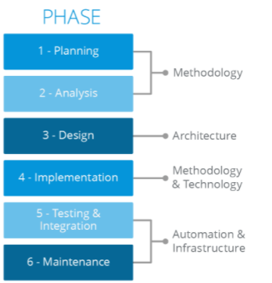

Figure 1: Processes when developing software (Hoek, 2018)

The methodology phase is to allow change in the business needs and adopt these changes. Architecture is there for a flexible solution design for allowing continuous business changes. Technology is where the company choses the right technology for the job to achieve best result. Automation is there to automate any time-consuming processes where infrastructure enables the project to create an infrastructure that can keep up with business changes and adaptations (Hoek, 2018).

For this study there will be a focus on the methodology phase (planning, analysis, and implementation) because of how the project manager communicates to the project developers can still be difficult in smaller businesses where the project manager has more than one project. This can cause a project to lose valuable time, resources, and money.

A project manager can easily fall behind or forget about important information when it is not immediately communicated to the project developers. With information being available at a faster pace, the project developers can work on the requirements quicker, this will improve productivity and increase the project’s success.

# Problem statement

As programmers, we want to keep the most important tabs open but lack the number of screens needed to achieve this. We are not regularly on our phones to read messages, thus making it harder for important messages to reach the team or developer. When developers have to look at their phones periodically it lowers productivity and creativity (Schrader, 2018).

This is common in smaller companies where the project manager is constantly busy with meetings for more than one project. Meetings are not always at the office and the scope or requirements of the project can quickly change. This causes the planning, analysis, and implementation phases in the software development life cycle to become difficult when not done correctly.

For this reason, this study proposes to develop an artifact that will allow project managers and project developers to have access to a way of communicating and to access important information during the day. The research will be conducted using design science as it involves the creation of an artifact with means to improve an already existing state of practices as well as researching existing knowledge (Vijay Vaishnavi, 2004).

1. Research questions to improve the design of the artifact are as follows:
2. How will design science help to develop the artifact?
3. What software will be needed to design the artifact?
4. What features need to be in the artifact?

# Project description

The goal of this study is to create an artifact that will improve communication in a company by minimizing the number of programs that are open on a programmer’s computer when working on a project. This study will give a solution to improve communication and productivity in the industry by using an artifact that project teams can use to send or upload important information.

The key concept is to have one web application showed on one screen in the office that is shared between project managers and project developers where everyone can see important information with ease. While focusing specifically on applications that can make it easier for project managers and project developers to communicate.

# Aims and objectives of project

This study proposes the development of a communication web application that can easily be viewed in an office by all employees to allow easy access to important communication regarding specific software development projects. The primary and secondary objectives for the study are provided next.

## Primary objective

To develop a web application for a South African software development company that allows for easy access to important communication relating to specific projects.

## Secondary objectives

1. Theoretical objectives

* Gain knowledge of design science research to guide the development of an artifact.
* To identify commonly used web applications in industry.

1. Empirical objectives

* To collect and analyse qualitative data in the form of an interview in order to understand what people in the software development industry need to make communication easier.
* To develop a communication web application that will provide easy access to desired communication.

# Procedures and methods that will be used

Data for this study will be collected through an interview by a project manager that is already in the industry and will take place during the planning phase. This study will use qualitative content analysis. Qualitative content analysis has been defined as “a research method for the subjective interpretation of the content of text data through the systematic classification process of coding and identifying themes or patterns” (Hsieh & Shannon, 2005). The process will begin during the early stages of data collection.

For this study, the most applicable research methodology is design science research. Research methodology based on information technology is an outcome of design science (Vijay Vaishnavi, 2004). It focuses on the performance and development of artifacts, intending to improve an already functional artifact. Research in this discipline is seen as improving and understanding human performance (Kuechler, 2012).

The Vaishnavi process model as well as why this process model was chosen, is elaborated upon in the next section.

# Process model for this research

With regards to Design Science Research this study will look at the Vaishnavi process model as well as the Peffers process model. The process model will establish the design as a coherent discipline (Mohammad Abooyee Ardakan, 2009) and aid to establish in what phase the project is at any given time.

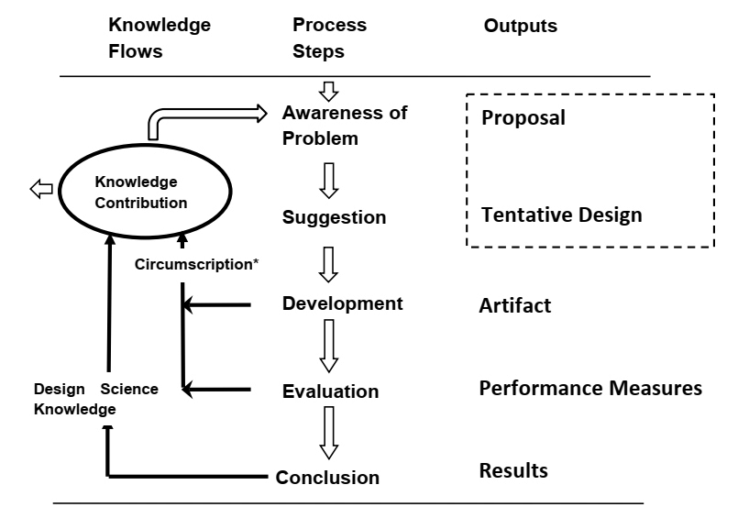

Figure 2: Vaishnavi Process Model (Vijay Vaishnavi, 2004)

The figure represents the process model by Vijay Vaishnavi (2004) an entails awareness of the problem, suggestion, development, evaluation, conclusion and will be discussed next.

1. Awareness of problem

Multiple sources can be used for an awareness of a research problem. This includes identifying problems in a reference discipline or a new development in the industry. Part of this phase is becoming aware of the main problem and considering criteria for evaluating the artifact when it is done.

1. Suggestion

This phase is where new functionality is envisioned. Non-repeatability has been criticized in this phase of the design science research method. A Tentative Design of a prototype forms part of the proposal if approved by the researcher. In all research methods, this creativity step has necessary analogs, as it creates curiosity to develop an artifact.

1. Development

If the Tentative Design is approved by the researcher further development and implementation take place in this phase. Implementation techniques will depend on the artifact that will be created. Formal proof may be needed to show the correctness of the design, for example constructing an algorithm.

1. Evaluation

By following the criteria set in the awareness of the problem phase, deviations of what was expected are noted and must be tentatively explained. The result in this phase can lead to a new design because the criteria are not met.

1. Conclusion

This phase is the end of the research cycle. The result of the research effort is typical, that of satisficing, where some deviations of the behavior of the artifact are revised.

# Why the Vaishnavi process model

Compared to the process model developed by Peffers, the Peffers process model splits the “Awareness of problem” into two phases called “Identify Problem & Motivate and Define Objectives of a Solution”; puts the “Suggestion and Development phases” together in a single phase called “Design & Development”; splits the “Evaluation” phase in two phases called “Demonstration and Evaluation”; changes the name of the “Conclusion” phase as “Communication”. A feature that distinguishes the Peffers model is the identification that from variety of contexts the design science research process can be initiated (Vijay Vaishnavi, 2004). This is shown in the figure bellow.

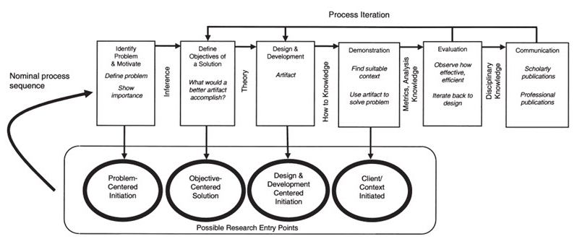

Figure 3: Peffers process model (Peffers, 2008)

The model is similar to other design science models, but of the scenario of this study there is no need for extra steps in the “Awareness of problem” or “Evaluation” process, as this will be decided by the project manager from the interview, while there is a need for more time in the “Development” phase because it is also being broken up into smaller phases. Phases are easy to go back to when something goes wrong.

Thus, the Vaishnavi Process Model will be used because it emphasises more on the detailed processes for generating design science knowledge and is easier to understand and follow.

# Approach to project management and project plan

Only in the development phase of the Vaishnavi process model will an agile methedology be used to aid in the development process.

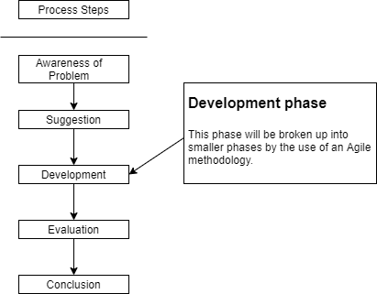

Figure 4: Where the Agile methodology will be applicable

## Agile methodology

According to Kumar and Bhatia (2012), this methodology gives an iterative, flexible design and building process. It includes a set of processes for comprehensive projects in environments that are constantly changing.

Agile was designed to overcome the old waterfall way of programming, which caused a project to fail after years because of something that happened in the early stages of the project. An overview of this methodology is creating smaller phases of the project called sprints. Where it looks to deploy a draft in the first sprint and a piece of software in the first couple of months. Feedback is needed from the customer on a daily basis, to ensure that the project is on track.

The most common and popular example of this methodology includes SCRUM, Feature Driven Development (FDD), Dynamic Systems Development Method (DSDM) and Crystal (Ismail, 2019).

The project will be broken up into 2-week periods and at each start of the two weeks the project will undergo a sprint planning discussion where the backlog items will be prioritized, and some tasks will be placed back in the sprint backlog. According to Campbell (2020) this will make complex work transparent and easier to understand.

At the end of each sprint, every task should be finished and ready to be released. Each task will also undergo a “show me”, “code review”, “merge” and a “QA”. This will reduce the risk of having bugs in the artifact because there is a user acceptance test layer.

# Description of development platform, resources, and environments that will be used

The artifact for this study will be a web application. According to Paul Stanley Software (Stanley), there are several advantages to creating a web application. Users do not have to install an application because every computer has a browser. It is easy to update, and users have direct access to these updates.

For the user interface, Vue.JS will be used as a binding framework because It is easy to understand, small in terms of size, and flexible (Vivek, 2018), as well as HTML, JavaScript, and CSS. For the backend Visual Studio’s Web API will be used and written in C#. The Database management system that will be used is SQL SERVER. The database and website will be hosted on Azure.

Factors that play a role in the environment are as follows:

## Rigour, validity, and reliability in quantitative research

In this study rigour is the quality of being extremely careful while working on the artifact. “Qualitative research is frequently criticised for lacking scientific rigour with poor justification of the methods adopted, lack of transparency in the analytical procedures and the findings being merely a collection of personal opinions subject to researcher bias” (Noble & Smith, 2015). Rigour will be established by the project manager that will be interviewed. Their answers will determent what features need to be in the web application.

Validity is the appropriateness of the processes, tools, and data. Validity can be tested when the choice of methodology is only appropriate when it can answer the research question, the desired outcome is valid according to the research question, the sampling of the data is appropriate, and conclusion and results are valid for the context and sample (Leung, 2015).

Reliability in this study refers to the replication of the results and processes. Then diverse paradigms are used in qualitative research the definition of reliability is demanding and epistemology is counterintuitive. Thus consistency is the essence of reliability for qualitative research (Leung, 2015).

## Ethical considerations

According to Enago Acadamy (2020) ethical consideration includes:

1. Validity

Specific research questions have to address the research design. The result must correlate with the conclusion and to the questions posed.

1. Voluntary participation and consent

No individual should feel that they have to participate in the study. This includes any type of deception or persuasion.

1. Sampling

An explanation is a need for why you want a particular group of participants and why some groups have been left out.

1. Confidentiality

Confidentiality needs to be respected, if any participant is at risk of harm, they need to be protected.

1. Risk of harm

Everything in our power needs to be done to protect study participants. The risk to benefit ratio needs to be focused on.

1. Research Methods

Consideration of what is the right approach to the study.

# Provisional chapter division

The study will include the following chapters:

1. Chapter 1: Introduction

In this chapter the underlying problem will be introduced as well as the methodology and principles that is going to be used. The objectives will be stated, and development platforms will be noted.

1. Chapter 2: Research methodology

In this chapter the research paradigm that is applicable to the study will be explained. It will also elaborate on the design science and why it was chosen for the study.

1. Chapter 3: Literature review

Existing literature will be discussed in this chapter as well as key concepts of the study.

1. Chapter 4: Data Analysis

In this chapter data gathering techniques will be discussed and how the data will be analysed to improve the existing concept.

1. Chapter 5: The artefact design

This chapter will be used to display the web application artifact.

1. Chapter 6: Conclusion

This chapter will conclude and give an overview of the study.

# Summary

This project proposal serves as an introduction to the research of the paper. The problem for project managers that have more than one project, communicating important information for each project can be challenging especially the planning, analysis, and implementation phases in the software development life cycle. Project developers that periodically look on their phones for messages can lower productivity and creativity.

The study will aim to develop a web application to improve communication in the industry. This web application should be developed according to the qualitative research done and if the requirements are not met then the application is of no use.

The objectives have been defined as well as what approach will be taken. The Vaishnavi process model will be followed to develop the application. An interview will be used to gather data on what information should display on the web application. Rigour, validity, and reliability will be considered when working on the artifact as well as ethical considerations when gathering data.

BIBLIOGRAPHY

Literature

Acadamy, E. (2020, 20 November). *What are the Ethical Considerations in Research Design?* <https://www.enago.com/academy/what-are-the-ethical-considerations-in-research-design/>

Campbell, J. (2020). *Scrum Methodology: Breaking Down the Scrum Framework*. <https://scrumexplainer.com/scrum/scrum-methodology/>

Dovleac, L. (2015). The role of new communication technologies in companies' sustainability. *Bulletin of the Transilvania University of Brasov. Economic Sciences. Series V*, *8*(1), 33.

EasyWorkNet. (2019, 27 December). *The Importance of Communication in Software Development Teams*. <https://www.easyworknet.com/web-development/importance-communication-software-development-teams/#:~:text=When%20it%20comes%20to%20software%20development%2C%20communication%20is,the%20solution%20to%20the%20client%20in%20good%20time>.

Hoek, J. v. d. (2018). *Pursuing a Full Agile Software Development Life Cycle*. <https://www.mendix.com/blog/pursuing-a-full-agile-software-lifecycle/>

Hsieh, H.-F., & Shannon, S. E. (2005). Three approaches to qualitative content analysis. *Qualitative health research*, *15*(9), 1278.

Ismail, K. (2019, 30 July). *A Look at the Most Common Project Management Methodologies*.

Kuechler, W. a. V., V. (2012). A framework for theory development in design science research: Multiple perspectives [Research]. 27. <https://citeseerx.ist.psu.edu/viewdoc/download?doi=10.1.1.348.7047&rep=rep1&type=pdf>

Kumar, G., & Bhatia, P. K. (2012). Impact of agile methodology on software development process. *International Journal of Computer Technology and Electronics Engineering (IJCTEE)*, *2*(4), 46-50.

Leung, L. (2015, September). *Validity, reliability, and generalizability in qualitative research*. <https://www.ncbi.nlm.nih.gov/pmc/articles/PMC4535087/>

Mohammad Abooyee Ardakan, K. M. (2009). Applying Design Research Method to IT Performance Management: Forming a New Solution. <https://scialert.net/fulltext/?doi=jas.2009.1227.1237>

Noble, H., & Smith, J. (2015). Issues of validity and reliability in qualitative research. *Evidence-based nursing*, *18*(2), 34-35.

Peffers, K. a. T., Tuure and Rothenberger, Marcus A. and Chatterjee, Samir. (2008). Peffers et al. (2008) A Design Science Research Methodology for Information Systems Research. <http://www.umfundi.barbourians.org/article/peffers2008design>

Schrader, J. (2018, 30 July). *How Your Cell Phone Habits Impact Your Productivity*. <https://www.psychologytoday.com/us/blog/why-bad-looks-good/201807/how-your-cell-phone-habits-impact-your-productivity>

Stanley, P. *Advantages of Web Applications*. <https://www.pssuk.com/AdvantagesWebApplications.aspx>

Vijay Vaishnavi, B. K., and Stacie Petter. (2004). DESIGN SCIENCE RESEARCH IN INFORMATION SYSTEMS. 62. <http://desrist.org/design-research-in-information-systems/>

Vivek. (2018, 14 October). *7 advantages of using Vue.JS | The Progressive Framewor*. <https://www.inkoop.io/blog/7-advantages-of-using-vue-js/#:~:text=%207%20advantages%20of%20using%20Vue.JS%20%7C%20The,popular%20among%20the%20web%20developers%20because...%20More%20>

Zambas, J. (2019, 5 February). *The Importance of Effective Communication in the Workplace*. <https://www.careeraddict.com/the-importance-of-effective-communication-in-the-workplace#:~:text=Effective%20communication%20in%20the%20workplace%20is%20an%20integral,effectively%2C%20the%20results%20are%20detrimental%20to%20the%20business>.